
KENBRIGHT ACTUARIAL AND FINANCIAL SERVICES LIMITED
LIABILITY VALUATION FOR GENERAL INSURANCE
INTERNAL TECHNICAL PROCEDURES
G | VERSION 1.0
 |  |  | JANUARY 2025
 |  |  | KAFS POLICY

Kenbright Actuarial & Financial Services Limited
26th Floor- Prism Towers – 3rd Ngong Avenue
P. O. Box 28281 – 00200
Nairobi, Kenya
kafs@kenbright.co.ke

 |  | 

DOCUMENT TRACKING
Revision History
Version | Author | Date | Revision
1.0 | Kenbright Actuarial and Financial Services Limited | January 2025 | Creation

Prepared for:

Kenbright Actuarial & Financial Services Limited
26th Floor, Prism Towers
3rd Ngong Avenue, Upperhill
P.O Box 28281 - 00200
Nairobi, Kenya

OUR REF
\\Kenbright\Internal Technical Procedures\General Insurance Valuation Manual

DOCUMENT PURPOSE
This document has been produced as part of the internal technical procedures for KAFS and provides guidance on valuation processes for life insurance business

DOCUMENT OWNERSHIP
The owner of this document is Kenbright Actuarial and Financial Services Limited
TABLE OF CONTENTS
1 INTRODUCTION 5
Background on Valuation of Technical Liabilities 5
Purpose 5
2 PROFESSIONAL JUDGEMENT IN ACTUARIAL WORK 6
Background on Professional Judgement 6
3 APPROACH 7
Assumptions 7
Reinsurance Recoveries 7
4 CLAIMS RESERVES UTILISATION ANALYSIS 8
IBNR Reserve 8
Outstanding Claims Reserves (OCR) 9
5 LIABILITY FOR INCURRED CLAIMS 10
Data Used in Estimating Claim Liabilities 10
Homogeneity and Credibility of Data 10
Paid, Outstanding and Incurred Claims Data 11
Claims Reserving 11
Overview: Run-off Triangles 13
Projections using Development Factors 14
IBNR Computation 15
Assumptions 15
Adjustments to Claims Data 16
6 RISK ADJUSTMENT 17
Bootstrapping Method 17
Cost of Capital (CoC) Method 18
7 DISCOUNTING 19
8 ASSUMPTIONS 20
Reinsurance Recoveries 20
9 REVIEW & SIGN-OFF 21
10 APPENDICES 22
Appendix 1: Sign-Off Template 22
11 APPROVAL 23

ABBREVIATIONS
NAME | DEFINITION
Actuary | A Fellow of the IFoA/Society of Actuaries
Actuarial Work | Work undertaken by a Member, or for which a Member is responsible, or in which a Member is involved, in their capacity as a person with actuarial skills on which the intended recipient of that work is entitled to rely. This may include carrying out calculations, modelling or the rendering of advice, recommendations, findings, or opinions
BCL | Basic Chain Ladder
BF | Bornhuetter Ferguson
GEP | Gross Earned Premium
IBNER | Incurred But Not Enough Reported
IBNR | Incurred But Not Reported
IRA | Insurance Regulatory Authority
KAFS | Kenbright Actuarial & Financial Services Limited
LC | Loss Component
LIC | Liability for Incurred Claims
LRC | Liability for Remaining Coverage
Member | A member, of any category, of the IFoA or any other acknowledged actuarial professional body
NSE | Nairobi Securities Exchange
OCR | Outstanding Claims Reserves
PAA | Premium Allocation Approach
RA | Risk Adjustment
ULAE | Unallocated Loss Adjustment Expenses
UPR | Unearned Premium Reserves
TAS | Technical Actuarial Standards
UPR | Unearned Premium Reserve
Valuation Date | The date at which liabilities of an insurer are determined, e.g. final day of a quarter or financial year

INTRODUCTION

Background on Valuation of Technical Liabilities
  - With the global adoption and implementation of the IFRS 17 Standard, the general insurance valuation procedures outlined below have been based on the Standard.
  - Insurance liabilities include both premium and claim liabilities which are recognized as Liability for Remaining Coverage and the Liability for Incurred Claims.
  - Under the IFRS 17 Standard, the claim liabilities are as identified below:
  - Liability for Incurred Claims (LIC) – mainly include claims incurred and reported prior to the valuation date but are yet to be settled and those which have been incurred but not yet reported. They include, among others:
    - Outstanding Claims Reported (OCR) are claim reserves incurred prior to the valuation date, which have been reported but are yet to be settled.
    - Incurred but not Reported (IBNR) reserves are for claims incurred prior to the valuation date but are yet to be reported.
    - Incurred but not Enough Reported (IBNER) are claims reserves to cater for inadequacies within the reserves held in respect of outstanding reported claims.
    - Unallocated Loss Adjustment Expenses (ULAE) means a reserve to cater for costs which are related to the settlement of claims, but which are not directly attributable to individual claim.
    - Risk Adjustment (RA) means the compensation an entity requires for bearing the uncertainty about the amount and timing of the cash flows that arise from non-financial risk as the entity fulfils insurance contracts.
  - In accordance with IFRS 17 (paragraph 36), the valuation of liabilities should also incorporate discounting to reflect the time value of money.

Purpose
  - The purpose of this course is to equip learners with comprehensive understanding of Liability for Incurred Claims (‘LIC’), Discounting and Risk Adjustment within the context of general insurance.

PROFESSIONAL JUDGEMENT IN ACTUARIAL WORK

Background on Professional Judgement

  - The International Actuarial Association (IAA) defines professional judgement under the International Standards of Actuarial Practice (ISAP) Glossary as the judgment of an actuary based on their actuarial training and experience. Key point is that the judgement needs to be based on actuarial principles.
  - It is important to provide guidance on how professional judgment is implemented. Key to ensuring that professional judgement is managed appropriately within the business is ensuring that a robust, clear, transparent, and consistent approach to decision making is in place.
  - This should involve embedding an expert judgement framework, including the creation of an expert judgement policy, suitable governance structures, appropriate standards, a fit-for-purpose expert judgement process and effective validation.
  - Providing clarity on the process and validation should provide a better and more consistent decision-making process for material judgements that need to be made across complex businesses.
  - Professional judgement will however not be applied to all actuarial work undertaken. In particular, according to the TAS 100 guidance note, the greater the complexity of a calculation the greater the likelihood that an element of judgement will be involved in the work, rendering it ‘technical actuarial work’.
  - Understanding the nature and complexity of work undertaken will be key in determining the extent to which professional judgement will be incorporated in the work.
  - Guidance is applied in a wide array of activities when undertaking actuarial work. These may include key activities such as scrutinizing data, choosing assumptions, constructing and using models and communicating information to users.
  - Taken at its simplest, professional judgement is involved in work requiring anything more than straightforward arithmetic calculations where no decisions are required on data, assumptions or methodology.

APPROACH

  - Before embarking on the liability valuation exercise, it is prudent to review previous liability reports prepared by the insurer’s internal team or the external actuary.
  - You will therefore need to review such reports over a one-year prior period. While reviewing such reports, take note of the key assumptions adopted and any recommendations put across.
  - For the key assumptions, take this into account while developing your own assumptions for the valuation exercise. Any large discrepancies should be noted down for discussion with the supervisor and the client.
  - For the recommendations, these should be reviewed and where appropriate, request for an update on the implementation of the recommendations from the insurer.
  - A summary of the implementation status should be included in the liability valuation model for review by the client.

Assumptions
  - When using the Basic Chain Ladder method, we assume that there is consistency in claims reporting and payment patterns.
  - Under the Bornhuetter-Fergusson method, we assume the ultimate values can be better projected by looking at the recent experience on loss ratio or any other a priori estimate in addition to the claims observed to date.
  - The key assumption under the Cape Cod method is that unreported claims will develop based on expected claims.
  - For Expected Loss Ratio Method, the assumption made is that ultimate claims will develop in line with the expected loss ratios adopted.

Reinsurance Recoveries
  - In calculating the Net IBN(E)R, we apply a reinsurance recovery rate per class of business to Gross IBN(E)R.
  - To estimate the reinsurance recovery rate for each class of business, we analyse the claims retention rates for the company over a specified period of years. These are then weighted on the estimated expected reserves over the same period.

CLAIMS RESERVES UTILISATION ANALYSIS

  - Before computing the claims reserves as at the current valuation date, track the utilisation of the claims (IBNR and Outstanding Claims) reserves estimates held as at the end of each of the past 3 years.
  - Do this by analysing the utilisation of both the IBNR and Outstanding Claims Reserves held as at the respective past valuation dates.
  - The claims reserves held at each valuation date is taken from the client’s Accounts and the analysis is done for each year under consideration per class of business.

IBNR Reserve
  - The utilisation of the IBNR reserve held at the end of each past year under review as at current valuation date is calculated as follows:
Let:
t = past year under review
U = IBNR utilisation
V = current Valuation Date
Utilisation (U) V = Total Claims incurred in years t and prior but reported in year (t + 1) to V
% Utilisation = U/IBNR t
Where:
Total Claims incurred in years t and prior but reported in year (t + 1) to V
=
Outstanding Claims as at V incurred in years t and prior but reported in year (t + 1) to V
+
Claims Paid in year (t + 1) to V, reported in year (t + 1) to V, but incurred in years t and prior

Outstanding Claims Reserves (OCR)
  - Utilisation analysis on the Outstanding Claims Reserve will also be done for the estimates held at the end of each of the past 3 years.
  - Proceed as follows;
Let:
t = past year under review
O = OCR utilisation
V = current Valuation Date
Utilisation (O) V = | Total Outstanding Claims as at V for claims incurred in years t and prior but  reported in year (t + 1) to V
% Utilisation = | O/OCR t
IBNER = | OCR t – O V
  - Peculiar utilisation in either case in a particular class of business should be investigated. This can be an indication of an anomaly, in which case, claims data can be reviewed for insights or clarification sought from the client.
  - Conduct a trend analysis for the utilisation results over a number of periods to identify a pattern that will guide you in making judgement on the peculiars of the utilisation figures.

LIABILITY FOR INCURRED CLAIMS

Data Used in Estimating Claim Liabilities
  - The availability of appropriate data and information is essential for accurately estimating claims liabilities. You can classify data as originating from either internal (from the insurer’s management information systems) or external (e.g. industry data) sources.
  - For large insurers you can rely solely on their own data to estimate claims liabilities, because they are able to generate the detailed claims and exposure data required for the exercise from their own management information systems.
  - However, if the insurer has a new line of business or has operations in a new geographical region, incorporate external data which will improve the reliability and credibility of the results.
  - On the other hand, for smaller insurers who may be limited in the internal data that they can generate, the data will be limited in its volume and thus its credibility, or the data may be unavailable due to systems limitations of the organization. For such situations incorporate external sources of data too.
  - You may however need to use a combination of both sources of internally generated data and external industry benchmarks in your reserving exercise. External information will particularly be valuable when selecting tail development factors, trend rates, and expected claim ratios.
  - For the purpose of this manual external data will include data from insurance companies of similar size or characteristic with the insurer under review, or industry statistics and reports published by the regulatory body or any other credible institution in which the insurer operates in.
  - However, exercise reasonable care using external data. There is a risk that external data may be misleading or irrelevant due to differences relating to: insurance products, case outstanding and settlement practices, insurers’ operations, geographic areas, and mix of business and product types.
  - As such, disclose any external data used, its source and your justification for incorporating the data in the reserving exercise. This should be included in the reserving model for review by other analysts and actuaries.

Homogeneity and Credibility of Data
  - As you may be aware, different lines of insurance exhibit different claim behaviours. Even within a single line of insurance, the characteristics of claims by sub coverage can differ significantly. For example, claims involving only property damage for motor insurance policies are generally reported and paid very quickly and have a relatively low severity (i.e., average settlement value) compared to liability claims arising from motor policies.
  - At a minimum, carry out the reserving exercise on a class wise basis as captured by the insurance company during underwriting.
  - However, you may further subdivide or aggregate the data depending on the volume and credibility of data available to allow for such analysis. Where this is done, disclose your considerations which should be clear to the users of the results including the peer review team and the client.
5.12. When separating data into groups for reserving you will be required to take into consideration the following key characteristics:
- Consistency of the coverage triggered by the claims in the group (i.e., group claims that will generally be subject to the same or similar laws, policy terms, claims handling, etc.)
- Volume of claim counts in the group
- Length of time to report the claim once an insured event has occurred (i.e., reporting patterns)
- Ability to develop an appropriate case outstanding estimate from earliest report through the life of the claim
- Length of time to settle the claim once it is reported (i.e., settlement or payment patterns)
- Likelihood of claim to reopen once it is settled
- Average settlement value (i.e., severity)

Paid, Outstanding and Incurred Claims Data
  - Incurred claims refer to claims which have been reported to the insurer. These include claims that have already been settled (paid claims) and those that the insurer has been notified about but are yet to be settled (outstanding claims).
  - In summary, you will realise that professional judgement is a key element when deciding on the volume of data, type of data, the source of external data and the grouping of data into homogenous groups. While guidance has been provided on these areas, any additional considerations will still be allowed as long as these are confirmed and approved by your peer reviewer and/or supervisor.

Claims Reserving
  - Claims reserves represent the insurer’s estimate of its current liabilities for claims that occurred on or prior to the valuation date but have not yet been paid.
  - The reserving process follows a four-phase approach:
- Exploration of the data to identify its key characteristics and possible anomalies. Balancing data to other verified sources should be undertaken at this point. Refer to the Valuation Data & Checks Manual for guidance on this.
- Application of appropriate techniques for estimating claims liabilities.
- Evaluation of the conflicting results of the various methods used, with an attempt to reconcile or explain the different outcomes. At this point, the projected ultimate amounts are evaluated in contexts outside their original frame of analysis.
- Monitoring of projections of claims development over subsequent calendar periods. Deviations of actual development from projected development of counts or amounts are one of the most useful diagnostic tools in evaluating the accuracy of claims liabilities estimates.
  - This manual focuses on the second approach by providing guidance on the various techniques to use in the reserving process.
  - Claim reserves are set aside for two main types of claims:
- outstanding reported claims; and
- incurred but not reported claims (IBNR).

General Steps in Reserving
  - The first step in reserving is putting together credible and adequate data. This is covered in the Valuation Data & Checks Manual.
  - Unless otherwise, analyse separately the claims reserves using both paid and reported claims (paid claims plus outstanding claims). Where you experience issues with the data available and both analyses cannot be performed, include this in the sign- off sheet, including reasons why the data is not sufficient for use. Discuss the same with your peer reviewer and supervisor before proceeding with the exercise.
  - Once you are comfortable with the data to use for the reserving analysis it is time to study the data further.
  - Review the data and identify the need for further re-classification to ensure that the data used is grouped into homogenous groups.
  - Study the claims patterns based on the claims amounts to identify any extreme values that will need to be excluded in the analysis. This is done by plotting the gross claims amounts for each homogenous group on a scatter plot, or any other appropriate tool, and identifying any outliers. Identification of extreme values will be subject to judgement and care should be taken to ensure that the exclusion is made on sound judgement.
  - You will however need to incorporate the excluded amounts in the reserving results. This is based on the idea that the occurrences may be repetitive and will therefore need to be allowed for in the results. You can include a loading to the claims reserves results based on the observed proportions of the large losses from the claims data.
  - Once any extreme values have been identified and removed, the adjusted data is now used to develop run-off/delay triangles, from which the selected valuation methodology will be applied.
  - You will be required to make a decision on the methodology to apply for the reserving exercise. Key considerations for each methodology are highlighted in the write-up section for each method (included in this guideline) which you will need to review to enable you make a decision. The methodologies used for reserving are likely to vary according to, among others:
- the class of business, in particular the length of the tail of the run-off of the liabilities and the exposure period of the insurance contracts
- the types of claim that have been incurred or may be expected to occur
- the extent and quality of the available data
- the age of the business or cohort of claims, and historical claim development information available
- historical trends and patterns
- the purpose of the reserving exercise
  - Identify at least two key methods to use for each homogenous group (these may be uniform for the whole portfolio) and have these signed-off by your peer reviewer and the supervisor.
  - Once the methods to apply have been identified, carry out the reserving exercise using the latest version of the valuation model and apply any judgment based on the results before discussing your results (including the assumptions adopted) with your peer reviewer.
  - Compile the aggregate results for review and sign-off. Ensure that the sign-off sheet is adequately populated to allow for other users to understand the assumptions and approach taken in carrying out the exercise. This will also allow for discussions with your peer reviewer and supervisor.
  - The final step will be generation of the draft valuation report, in the prescribed format, which is further subjected to peer review.
  - The Actuarial Manager will be in charge of communicating the results with the client and once these are finalised, a final valuation report will be prepared and submitted to the client under the directive of the Lead Actuary.

Overview: Run-off Triangles
  - Run-off/delay triangles are important for forecasting future claims amounts. They are important when there may be a time lag after the loss until the full extent of the claims which have to be paid are known. They provide a method of tabulating claims data and studying the underlying statistical model.
  - The period in which a loss happens, and the insurer was on risk is called the accident/loss period. This may be categorised as years or quarters, or any other identified period chosen to study the claims. The number of periods until a payment is made is called the delay, or development period. The cumulative claims data is divided up by the accident/loss period and the development period. An example of classification is as shown in the figure below.
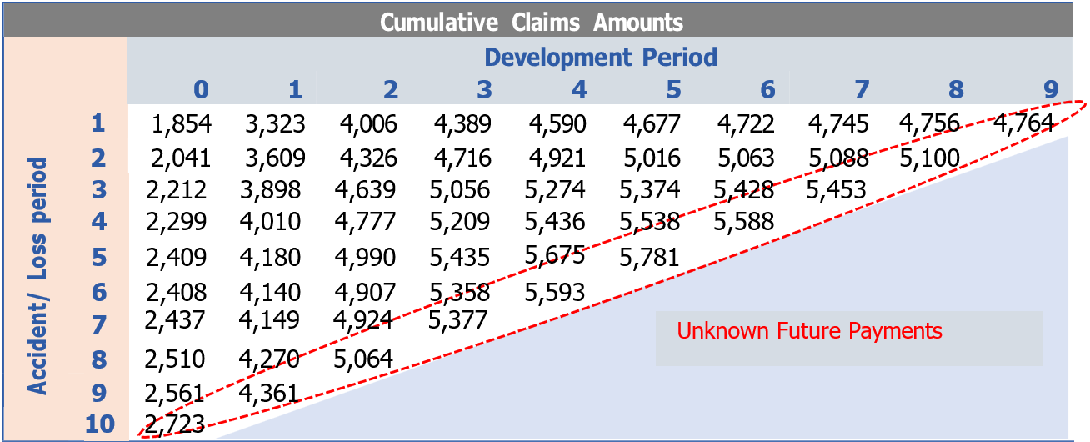
  - Each row in the triangle represents an origin period which defines a cohort of claims while the columns represent development periods, which show how the cohort of claims relating to a particular origin period develop over time.
  - Note that particular periods are represented by the diagonals in the triangle. For example, the circled diagonal includes all payments made during the most recent period shown, i.e. period 10, which could be the recent period (as well as past periods since the triangle contains cumulative entries).
  - Also note that the upper left corner represents ‘known’ past claims amounts, while the lower right corner represents ‘unknown’ future amounts. The main aim of reserving is to look at methods of estimating the unknown figures to complete the lower right triangle.
  - For each accident/loss period, the difference between the figure in the extreme right-hand column and the total amount paid so far will give us the estimate of the amount we need to hold currently to meet future liabilities arising.
  - Claims are analysed in cohorts, and it is important that each claim is allocated to the correct cohort.
  - One method of recording data is by accident-period basis where claims development is clustered by the period an accident/loss has occurred. In that respect, such data would include incurred but not yet reported (IBNR) claims.
  - Claims paid in the period the accident/loss takes place are said to be paid in development period 0, claims paid in the following period are said to be paid in development period 1 and so on. The proportion of payments in various development period arising from the losses in an accident/loss period is known as the Loss Development Pattern.
  - Classes of insurance for which the Loss Development Pattern spreads out over a number of development period (such as Liability Insurance) are said to be Long Tail Business while classes of insurance for which the Loss Development Pattern is short (such as Fire and Theft Motor) are said to be Short Tail Business.
  - Another method of recording data is by underwriting period. This procedure would group claims by the time policies were written rather than when they occurred. This method would therefore include IBNR claims, and claims that are yet to occur, if they relate to a policy written in the underwriting period.
  - A third method of grouping claims is by reporting period. This method would not include IBNR claims as all claims would be allocated to the period in which they were reported.

Projections using Development Factors
  - An insurer's liabilities for outstanding claims at a given date (the valuation date) are the present value of claim payments, to be made after the valuation date, on claims which, under the terms of its contracts, arose on or before the valuation date plus the present value of the insurer's internal costs directly related to administering and settling those payments.
  - The basic assumption made in estimating outstanding claims liabilities concerns the run-off pattern. The simplest assumption is that claims will emerge in a similar way in each accident/loss period. The proportionate increases in the known cumulative claims from one development period to the next can then be used to calculate the expected cumulative claims for future development periods.
  - Note that the ratios that are used to project future claims are known as development factors or link ratios.
  - A development factor may describe the ratio between cumulative claim amounts in consecutive periods or between periods over a longer period. In the table below we calculate development factors for the ratios between consecutive periods. For example, the development factors in the highlighted column are derived by dividing the cumulative payments in column 1 by the corresponding payments in column 0.
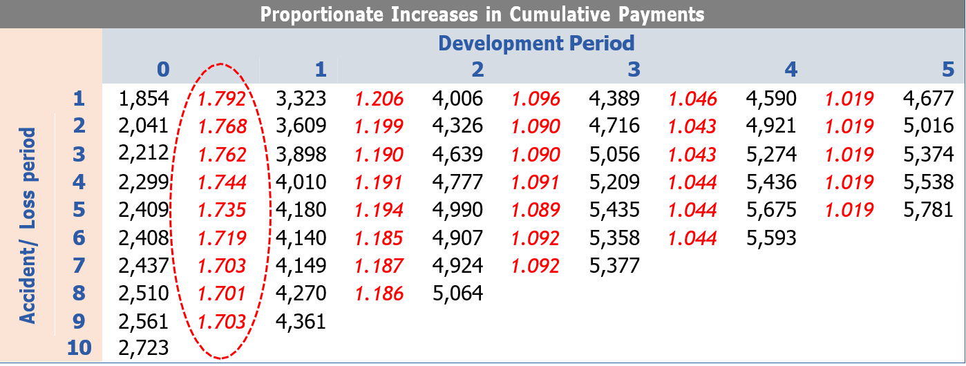
  - For each accident/loss period from there is a different ratio for the increase in cumulative payments from development period 0 to development period 1.
  - The development factors will always be greater than or equal to 1.
  - The choice on which development factor to apply when projecting forward for accident/loss period 10 is subject to judgement. For example, for a conservative approach, it might be best to take the largest ratio, i.e. 1.792. Other options are using the lowest ratio, a simple average or weighted average of the ratios.

IBNR Computation
  - Reserves are computed using the Basic Chain Ladder (BCL), the Bornhuetter-Ferguson (BF), Loss Ratio (LR) and the Cape Cod methods on either quarterly basis or annual basis.
  - The choice of method used for each class is guided by the availability of credible volume of data.
  - Under the Basic Chain Ladder (BCL) method, reported claims data are displayed in the development triangles and age to age factors calculated. For each payment lag, average age to age factors is computed which are used to get cumulative development factors (CDF). The cumulative development factors show the development pattern of the claims that help project ultimate claims using a triangulation approach.
  - The Bornhuetter-Fergusson (BF) method is a blend between the basic chain ladder method and what is expected based on the recent experience of the class. In this method, historical experience is retained as part of the estimate of ultimate claims but is not the basis from which future claim activity is projected. Instead, we derive future claim activity from a priori estimate of our expectation.
  - The Bornhuetter-Fergusson method is adopted where there is uncertainty in the claims development trends. In this regard, the basic chain ladder method depends on the stability of claims development. The Bornhuetter - Fergusson method considers both the claims developed to date (which depends on reporting/payment patterns) and the expected claims based on recent experience of the class, hence improving the accuracy of the estimate.
  - The Cape Cod method assumes a constant ultimate loss ratio for each past accident years. The ultimate loss ratio is estimated by dividing the reported losses for all years by the reported exposures. The exposure is estimated by multiplying the exposure measure by the percentage of losses that have developed. Earned premiums are used as the exposure measure. The reserve is then estimated as the percentage of unreported expected ultimate claims.
  - The Expected Loss Ratio method projects ultimate claims relative to earned premiums, based on expected loss ratios. This method is employed for classes where past data available is considered inadequate for triangulation.
  - IBNR is calculated as the projected ultimate claims less actual claims incurred to date.

Assumptions
  - When using the Basic Chain Ladder method, we assume that there is consistency in claims reporting and payment patterns.
  - Under the Bornhuetter-Fergusson method, we assume the ultimate values can be better projected by looking at the recent experience on loss ratio or any other a priori estimate in addition to the claims observed to date.
  - The key assumption under the Cape Cod method is that unreported claims will develop based on expected claims.
  - For Expected Loss Ratio Method, the assumption made is that ultimate claims will develop in line with the expected loss ratios adopted.

Adjustments to Claims Data
  - Appropriate adjustments are made for large claims/outliers that are expected to distort the estimated development of future claims.
  - Where adjustments are made in the data used for large/outlier claims, consideration are further taken of whether such experience can be reasonably expected to recur in future and the expected impact on claims. Where applicable, explicit loadings are made in future reserve estimates.

RISK ADJUSTMENT

  - The Risk Adjustment (“RA”) is the compensation an entity requires for bearing the uncertainty about the amount and timing of the cash flows that arise from non-financial risk as the entity fulfils insurance contracts.
  - The Bootstrapping method is used to calculate the Risk Adjustment as at the Valuation Date, with the Cost of Capital method used as an alternative where Bootstrapping is not applicable.
  - As required by the IRA circular CONF/IRA/00/001/03 dated 22nd March 2023, "The Implementation of the Standard," both the Bootstrapping and Cost of Capital methods are computed at 75% confidence level.

Bootstrapping Method
  - The Bootstrapping method is a statistical technique that resamples historical claims data to generate a distribution of possible future outcomes, allowing for a detailed and realistic estimation of the RA. It uses a two-stage bootstrapping approach.
  - In the first stage an ordinary Basic Chain Ladder (“BCL”) method is applied to a cumulative claim’s triangle. The calculated the scaled Pearson residuals are bootstrapped R times to forecast future incremental claims payments via the standard BCL method.
  - In the second stage, a simulation process error is run using the bootstrap value as the mean and assuming over-dispersed Poisson process distribution. The IBNR reserves generated by this technique form the predictive distribution from which summary statistics including the mean, prediction error, and quantiles can be computed.
  - This resampling technique utilizes historical data to generate stochastic scenarios, drawing upon past observations as potential future outcomes rather than theoretical distributions. This results of the production of a full distribution of the claims from which the mean and the 75th percentile reserves will be estimated. The Risk Adjustment is then derived from the two estimates as shown below:
$$Risk Margin at 75\% Confidence Level=IBNR at 75\% Confidence Level- Mean IBNR$$

Cost of Capital (CoC) Method
  - The Cost of Capital approach determines the RA by estimating the compensation required for taking on insurance risks, reflecting the opportunity cost of holding capital.
  - The rates used for this approach are derived from the Risk Based Capital (‘RBC’) Model provided by the IRA. The RBC model provides the risk charges for each line of business under Capital Form 41_1B.
  - It also provides for an additional Catastrophe Risk Charge of 2%.
  - The Cost of Capital rates are determined at 75% confidence level and using 10% as the average required return on investment, as shown in the table below:
COST OF CAPITAL APPROACH (USING REGULATORY CAPITAL MODEL AT 75% PERCENTILE, % Of CLAIMS)
 | Minimum Capital Requirement (MCR) |  |  | PCR / SCR
Insurance Class | Claim  Reserves | Catastrophe | MCR  Capital |  | Solvency  Adjustment |  | Regulatory  Capital | Selected  Cost of Capital  Rate |  | Risk Adjustment
Aviation | 29% | 2% | 31% |  | 1 |  | 31% | 10% |  | 3.10%
Engineering | 4% | 2% | 6% |  | 1 |  | 6% | 10% |  | 0.60%
Fire Domestic | 2% | 2% | 4% |  | 1 |  | 4% | 10% |  | 0.40%
Fire Industrial | 6% | 2% | 8% |  | 1 |  | 8% | 10% |  | 0.80%
Liability | 9% | 2% | 11% |  | 1 |  | 11% | 10% |  | 1.10%
Marine | 8% | 2% | 10% |  | 1 |  | 10% | 10% |  | 1.00%
Motor Private | 5% | 2% | 7% |  | 1 |  | 7% | 10% |  | 0.70%
Motor Commercial | 3% | 2% | 5% |  | 1 |  | 5% | 10% |  | 0.50%
Motor Commercial PSV | 3% | 2% | 5% |  | 1 |  | 5% | 10% |  | 0.50%
Personal Accident | 9% | 2% | 11% |  | 1 |  | 11% | 10% |  | 1.10%
Theft | 4% | 2% | 6% |  | 1 |  | 6% | 10% |  | 0.60%
Workmen’s' Compensation | 19% | 2% | 21% |  | 1 |  | 21% | 10% |  | 2.10%
Medical | 13% | 2% | 15% |  | 1 |  | 15% | 10% |  | 1.50%
Miscellaneous | 6% | 2% | 8% |  | 1 |  | 8% | 10% |  | 0.80%
Source: TASK IFRS 17 Risk Adjustment Guidance

DISCOUNTING

  - IFRS 17 Standard has provided two discounting approaches for insurance liabilities. These include:
- Bottom-up approach- Includes risk-free rates (e.g., government bond yield curve) and adds an illiquidity premium to account for the lower liquidity of insurance contracts.
- Top-down approach- Considers the overall risk profile of the entire insurance portfolio to derive discount rates.
  - The bottom-up approach is used to discount claim liabilities as at the Valuation Date.
  - Using the bottom-up approach, discount rates are determined by adjusting a liquid risk-free yield curve to account for differences in the liquidity characteristics between the financial instruments underlying market-observed rates and the insurance contracts.
  - The calculation of discount rates under the bottom-up approach are illustrated in the formula below:
Discount Rate= Risk-Free Rate + Illiquidity Premium
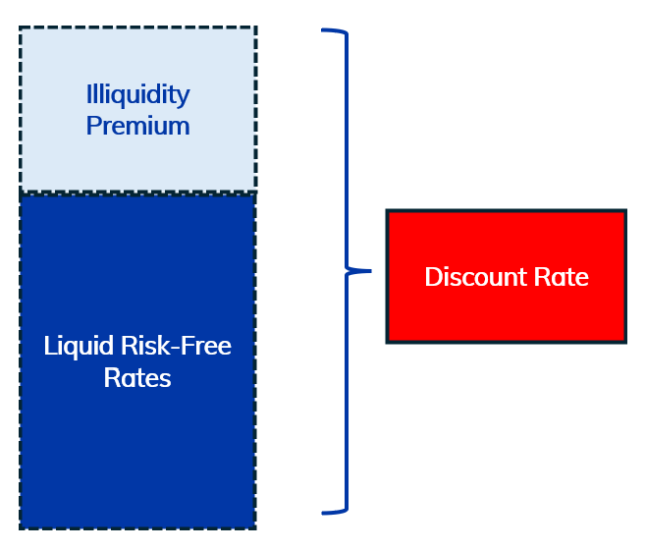
  - In the context of IFRS 17 for insurance companies, the illiquidity premium represents the additional return investors expect for holding assets that are less liquid as opposed to highly secure investments like government bonds.
  - The risk-free rate applied is the government bond yield curve published by the Nairobi Securities Exchange (“NSE”) in line with the statutory prescription by the IRA.
  - No discounting is applied for periods below 12 Months.

ASSUMPTIONS
  - When using the Basic Chain Ladder method, we assume that there is consistency in claims reporting and payment patterns.
  - Under the Bornhuetter-Fergusson method, we assume the ultimate values can be better projected by looking at the recent experience on loss ratio or any other a priori estimate in addition to the claims observed to date.
  - The key assumption under the Cape Cod method is that unreported claims will develop based on expected claims.
  - For Expected Loss Ratio Method, the assumption made is that ultimate claims will develop in line with the expected loss ratios adopted.

Reinsurance Recoveries
  - In calculating the Net IBN(E)R, we apply a reinsurance recovery rate per class of business to the Gross IBN(E)R.
  - To estimate the reinsurance recovery rate for each class of business, we analyse the claims retention rates for the company over a specified period of years. These are then weighted on the estimated expected reserves over the same period.

REVIEW & SIGN-OFF
  - Upon completion of the determination of the Liabilities for Incurred Claims, include a summary of any assumptions adopted for review and sign-off. A sign-off template is attached in the appendix.
  - Forward the computations for review.

APPENDICES

Appendix 1: Sign-Off Template

Sign-off
Statement by the Lead Analyst
I confirm that I have carried out this work in line with the applicable KAFS Internal Technical Policy and Procedure. Below is a summary of the key assumptions made:
Key Assumptions
1
2
3
4
5
Name:
Date:
Statement by Peer Reviewer
I have reviewed this work in line with the KAFS Work Review Policy and discussed all issues encountered with the Lead Analyst. Below are my review comments:
Review Comments
1
2
3
4
5
Name:
Date:
Statement by Supervisor
I have reviewed this work and discussed the issues encountered and the key assumptions made by the Lead Analyst. I confirm that the results are in order.
Name:
Date:

APPROVAL
Thus, adopted and signed by the management and Chief Actuary of KAFS in January 2025.
APPROVED BY
Ezekiel Macharia
Chief Actuary & Managing Director – Kenbright Actuarial and Financial Services Limited

Date: January 2025
Signed:



About Us

Kenbright Actuarial & Financial Services Limited (KAFS)
Prism Towers, 26th Floor
3rd Ngong Avenue, Nairobi
Kenya
www.kenbright.co.ke

Customer Service Lines: +254 (020) 22 111 52

Document Version

January 2025

Version 1.0: Creation

Reproduction – in total or in part – only with the permission of KAFS.

Key Contacts

E Macharia, FIA C.Act, FeASK
Chief Actuary & Managing Director
E-mail: ezekiel@kenbright.africa
Phone: +254 722 540 045

